From the Customs Enforcement Manual
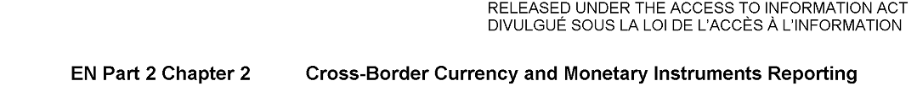

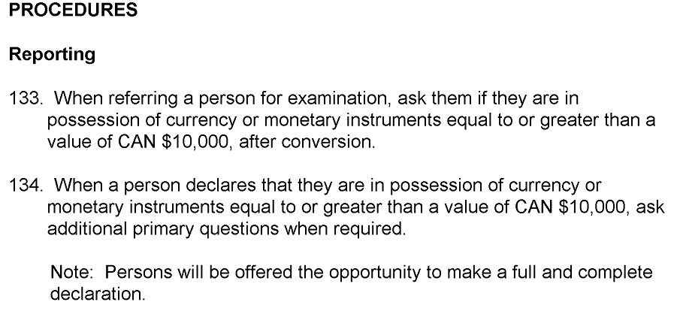

Part 3 Questioning
